**Identification and Validation of Cell-free DNA Methylation Biomarker for Human Brain Cancers**

**Research Goal**

Glioblastoma (GBM) is a primary neuro-epithelial tumor characterized with extremely aggressive clinical phenotype and a poor prognosis. Early diagnosis to GBM is one of most effective approach to rise the 3-year survival ratio (from 1% to 20%). In my previous study, we shown high proliferation ratio and high death ratio of cancer cells provided large number of tissue-specific DNA methylation signals (10,000 copies/mL) which could be applied for mapping the cell-free DNA methylation signals to the tissue-of-origin of cancer organs. The overarching goal of this study is to identify and validate an early diagnostic biomarker panel for glioblastoma. Meanwhile, we will also investigate the earliest time when the cell-free DNA methylation can be detected before diagnosis and normal individuals with high genetic risks. The proposed study is highly significant and important, as the circulating cell free DNA methylation-based biomarkers will not only help clinicians to diagnose or surveillance disease progress, but also provide important clues to understand the pathogenic mechanisms of glioblastoma.

**Aim 1:** To identify and validate key circulating DNA methylation-based predictive biomarkers in PMRP well annotated glioblastoma samples.

**Aim 2:** To identify and validate key circulating DNA methylation-based predictive and prognostic biomarkers in PMRP well annotated glioblastoma samples.

**Aim 3:** To confirm the earliest time of the DNA methylation signals through checking the cell-free DNA methylation status to serums before diagnosis in PMRP glioblastoma samples.

**Aim 4:** To test the hypothesis that whether cell-free DNA methylation signals could be detected in high risk individuals who have high polygenic-risk-score.

**Public Health Relevance**

Circulating cell-free DNA methylation have been demonstrated to be most potential biomarkers for cancer early diagnosis and prognosis. Current, FDA have approved one DNA methylation early screening DNA methylation biomarker for colon cancer (*SEPT9*) and another methylation-based biomarker (*SHOX2*) for lung cancer is under-evaluation by FDA. However, DNA methylation biomarker for glioblastoma is still unknown. In this study, we will use huge DNA methylation dataset collected from The Cancer Genome Atlas (TCGA) project and Gene Expression Omnibus (GEO) database to identify the most potential methylation biomarkers for diagnosis and prognosis and then validated them in Marshfield Clinic Glioblastoma samples. Furthermore, we could make full use of longitudinal study design of PMRP to confirm the earliest time of DNA methylation signals before diagnosis and test the hypothesis whether high polygenic-risk-score individuals will have higher frequent abnormal methylation signals.

**Background**

Glioblastoma (GBM) is a primary neuro-epithelial tumor characterized with extremely aggressive clinical phenotype and a poor prognosis (5-year survival ratio of 8%). Early diagnosis to GBM is one of most effective approach to rise the 3-year survival ratio (from 1% to 20%). Currently, the most common diagnosis approach for glioblastoma is Magnetic resonance imaging (MRI), computerized tomography (CT) and biopsy, however, the high cost of MRI, radiation risk of provided tons of concerns from current clinical services. What’s more, MRI and CT cannot provide extra glioblastoma information such as glioma grading, subtype and prognostic measures. Biopsy could provide more information, however, it is invasive treatment and will bring extra risk for cancer metastasis. Molecular diagnosis have been becoming one of most important approaches to provide accurate diagnosis with fast speed and low-cost. Compared with other molecular variants such as SNPs, CNV, mRNA and miRNAs, DNA methylation have been proved to be most powerful biomarker for cancer diagnosis since its flexible stability. Genome-wide DNA hypo-methylation and locally hyper-methylation in the promoter region of tumor suppressor genes have been observed for all most all cancer types(1, 2) and these abnormal change have been demonstrated to be earlier than most symptoms(3, 4) which can be detected by MRI or CT(5-7). In our previous research, we found DNA methylation could be used to silence tumor suppressor genes(8, 9), miRNAs(10), mRNAs(11) and drug metabolic genes (12) to play roles in cancer development(13), metastasis(14) and chemotherapy resistance(15). Recently, we demonstrated that circulating cell-free DNA methylation could provide a novel approach to help the clinicians to diagnosis or predict cancers in an early stage and with a non-invasive way (16). What’s more, compared with mutations, DNA methylation have more biomarkers to be selected for diagnosis and prognosis. According to recently research, DNA methylation abnormal in individual cancer patients could come up to 103-104 while mutations (driver mutation and passenger mutation) is only 10-102 and therefore majority of the gene expression changes are caused by DNA methylation rather than mutation even that mutation and DNA methylation could work together to silence certain genes, such as TP53(17).

In the past decades, DNA methylation research in glioblastoma was very limited and mainly focus on several identified genes, such as MGMT (18, 19), CD133 (20), ARF1 (21) and mainly focus on prognosis. Several of non-coding RNA was also reported to be abnormal in GBM, such as miR-153(22), miR-181(23). Even though there were several genome-wide DNA methylation studies to identify differential DNA methylation (24-27), limited sample size make it difficult to make solid conclusion (24-30), especially normal controls are difficult to obtained. What’s more, there are only few study was conducted to do DNA methylation biomarkers for glioblastoma based on circulating cell-free DNA which might be caused by the worry from blood-brain barrier. I found 6 papers (31-36) in Pubmed with the [keywords](https://www.ncbi.nlm.nih.gov/pubmed/?term=((cell-free+or+circulating)+AND+glioblastoma)+AND+methylation) of cell-free or circulating, methylation and glioblastoma in all the field. Giselle and his colleagues found circulating cell-free DNA could be prognostic and molecular marker for brain tumor under Perillyl Alcohol-based therapy (37).

We also collected 516 lower grade glioma (LGG) and 1,198 normal PBMC genome-wide DNA methylation data to increase the power to identify GBM biomarkers.

In this study, we collected 2,462 genome-wide DNA methylation data (Illumina methylation 850K/450K/27K beadchip) for glioblastoma and more than 12,359 other cancer genome-wide DNA methylation dataset (HM450K). Meanwhile, the RNA-seq data are also available for these methylation dataset. Therefore, we can identify all the hyper-methylated genes which are low-expression in glioblastoma or hypo-methylated genes while high-expression in glioblastoma. We also collected more than 1,198 normal PBMC HM450 data which can be used to be background control to identify hyper-methylated DNA fragments which are non-methylated for blood cells so that we can obtain the most potential hyper-methylation biomarkers for glioblastoma in the blood and without the interference from blood cell DNA methylation signals.

**Preliminary Studies**

**Genome-wide DNA methylation of glioblastoma revealed numerous DNA methylation diagnostic biomarkers**

In order to identify DNA methylation biomarker for GBM diagnosis and prognosis, we collected genome-wide DNA methylation data from public database including GEO(38) and Arrayexpress(39). We found 15 public dataset are involved in genome-wide DNA methylation research (composed by methylation 27K, 450K and 850K microarray) in brain and brain cancer research (**Figure 1, left panel**). These dataset include 1379 brain cancer samples and 1083 non-cancer brain. In order to design precision sequencing primers for target bisulfite sequencing, we collected normal brain genome-wide bisulfite sequencing data for human brain from Human Roadmap Project (40). In order to make our research more solid, we also collected other cancer samples so that we can evaluated the performance of the markers in other cancers. We collected NCI-60 cancer cell line methylome data based on HM450K array were downloaded from CellMiner database(41) and the cancer genome atlas (TCGA) DNA methylation data for 23 cancers (42). We plan to apply three stage research strategy to identify and evaluate the diagnostic biomarker for brain cancer including LGG and GBM (**Figure 2**). In the discovery stage, we integrate all the methylation 450K microarray data (including 516 LGG, 365 GBM and 589 non-tumor brain tissues) to identify potential diagnostic biomarkers. PCA analysis were applied to identify and to remove non-brain samples. We found 21 samples are actually blood samples which were confirmed by GEO clinical information and we also removed another 9 samples which are suspicious (**Figure 2**). For the discovery dataset, we have detailed clinical characteristics including age, gender. We collected these confounders and we found the samples are composed by 709 male, 565 female samples and 196 gender-missing samples. However, for the validation dataset (HM27K and 850K), clinical information are missing in GEO database. In order to identify the potential biomarkers which can be applied in non-invasive cell-free DNA (cfDNA) methylation based brain cancer diagnosis with plasma samples, we require the DNA methylation biomarker have distinct DNA methylation status with blood cells. We then adopted human PBMC, CD4+ and CD8+ T cell DNA methylation from our previous research (43-45) to be background noise control. In addition, cell-free DNA methylation data status of 75 normal samples were retracted from my previous cell-free DNA methylation research to increase the biomarker specificity (16). We removed all the probes which contain single nucleotide polymorphisms (SNPs) to avoid the influence from genetic variation in the population and differential hybridization between probe and DNA molecular. As we known, DNA methylation mainly played roles in gene expression regulation, we aim to identify function DNA methylation markers and therefore we collected transcriptional factor binding sites (TFBS), H3K4me1, H3K4me3, H3K27ac and DNase I hyper-sensitive site (DHS) data from ENCODE project (46).

A B C

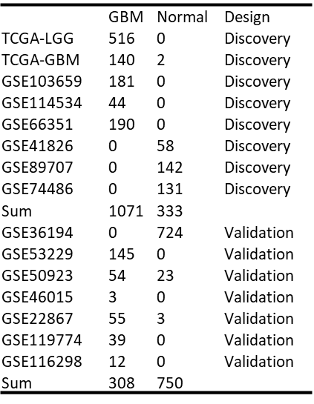 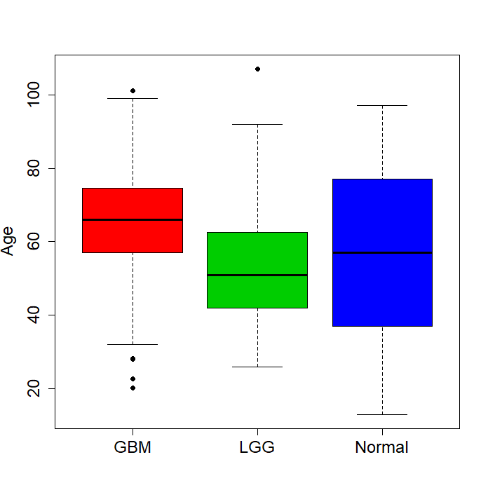 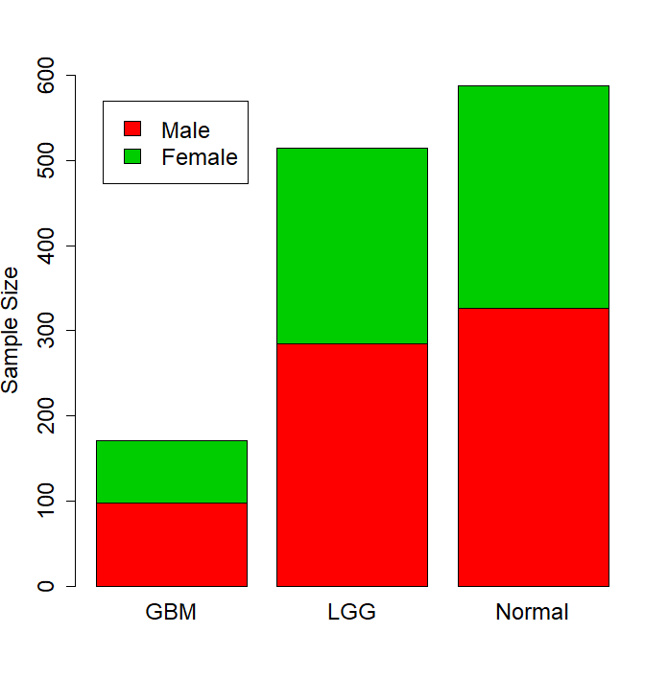

Figure 1. Dataset and clinical characteristic for MCRI LGG/GBM methylation biomarker identification project. A: sample size for each public dataset. B: age distribution for GBM/LGG and normal. C: gender distribution.

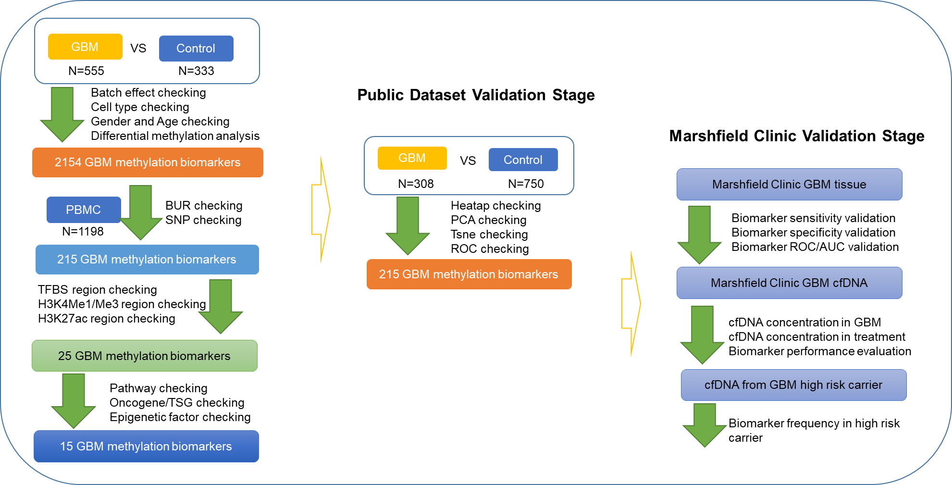

Figure 2. Flowchart of DNA methylation based biomarker for GBM. We designed a three-stage biomarker identification strategy to identify brain cancer (LGG and GBM) diagnostic and prognostic biomarker systems. We first scan the whole human methylome to obtain the most potential functional DNA methylation biomarkers and these makers were evaluated by another independent dataset between GBM and non-tumor brain samples and apply multiple machine learning method to form the best diagnosis and prognosis biomarker panel. Finally, we will evaluate the panel in MRCI samples including solid tumor, cell-free DNA from LGG/GBM cancer patient and high-risk allele carriers.

We check the integrated DNA methylation dataset with principle component analysis and to evaluate clinical confounders in the whole dataset. We found gender and dataset don’t provided strong variations between LGG/GBM and normal samples (**Figure 3A and 3C**) while the major variation came from sample types including LGG, GBM and control brain samples(**Figure 3B**). The PC1 and PC2 contributed almost 80% variations. We apply logistic regression to identify LGG and GBM differential methylation loci adjusted by age and gender: (LGG/GBM ~ CpGs+ Age+ Gender) and the methylation status of 60, 920 CpGs are significantly different compared with non-tumor brain tissues. When we filter with 1) blood un-methylated loci (BUL) from 1198 PBMC samples 2) remove probes with SNPs and 3) methylation change (delta beta) > 0.2 and decrease the candidate biomarkers to 3,688. Actually, if we apply higher delta beta as the threshold, we can disease the candidate markers to 285 (delta beta=0.4, **Figure 4A**). With the functional genomic region as the filter, we decease the biomarker to 3,385 when we require the biomarker should be annotated by all the ENCODE regulatory elements (N=6, include TFBS, H3K4me1, H3K4me3, H3K27ac, DHS and BUR of PBMC)

A B C

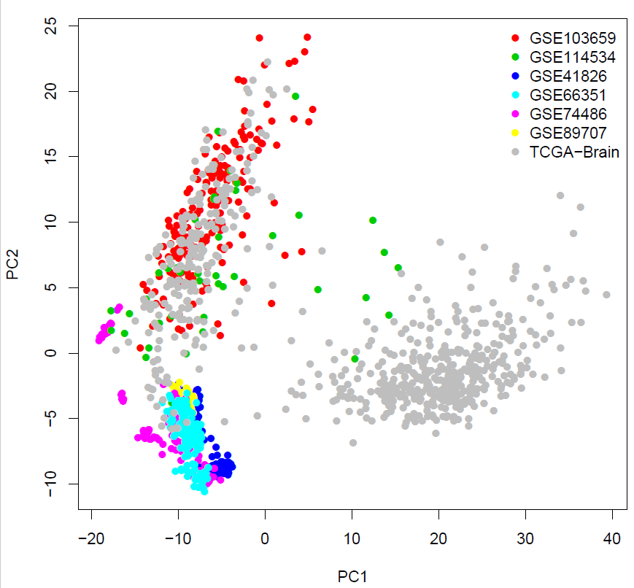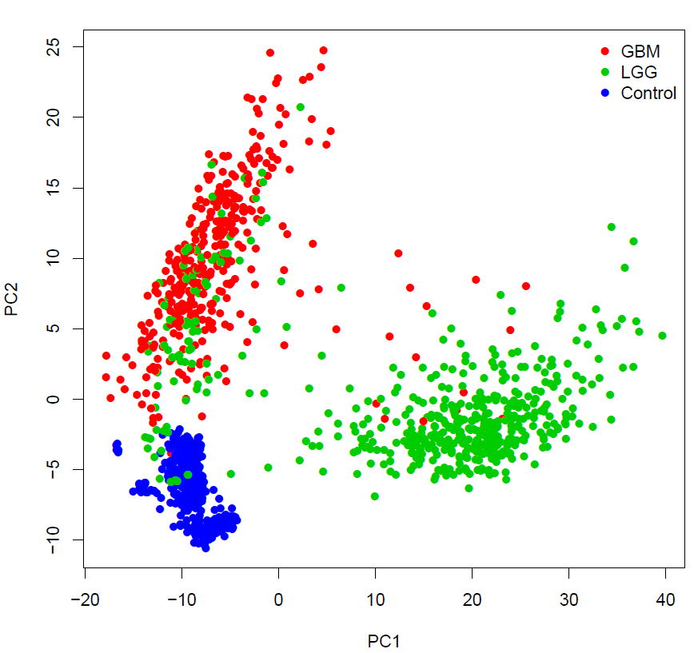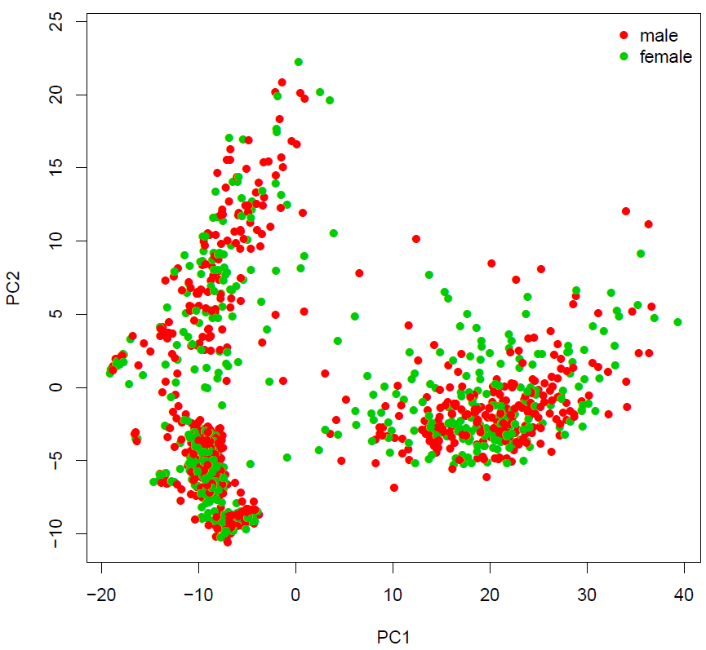

Figure 3. PCA analysis to discovery dataset to evaluate the data structure. In the discovery stage, we have 7 dataset which are merged by methylation 450K microarray (HM450K). HM450K includes 450,000 probes and provided genome-wide assay to human methylation profile.

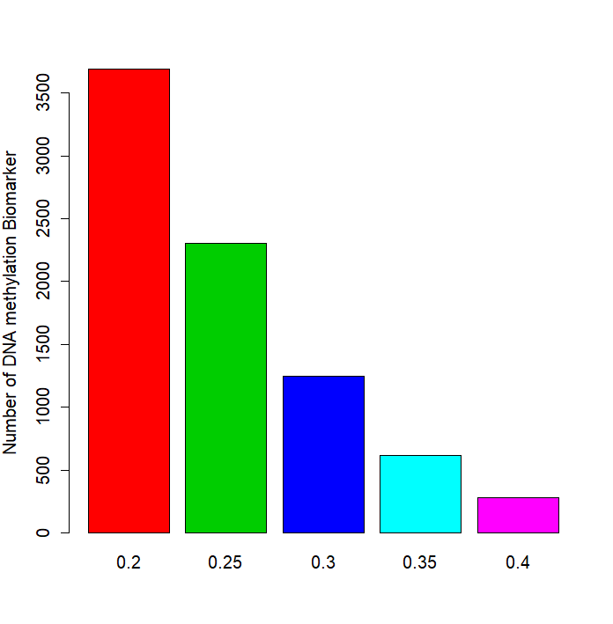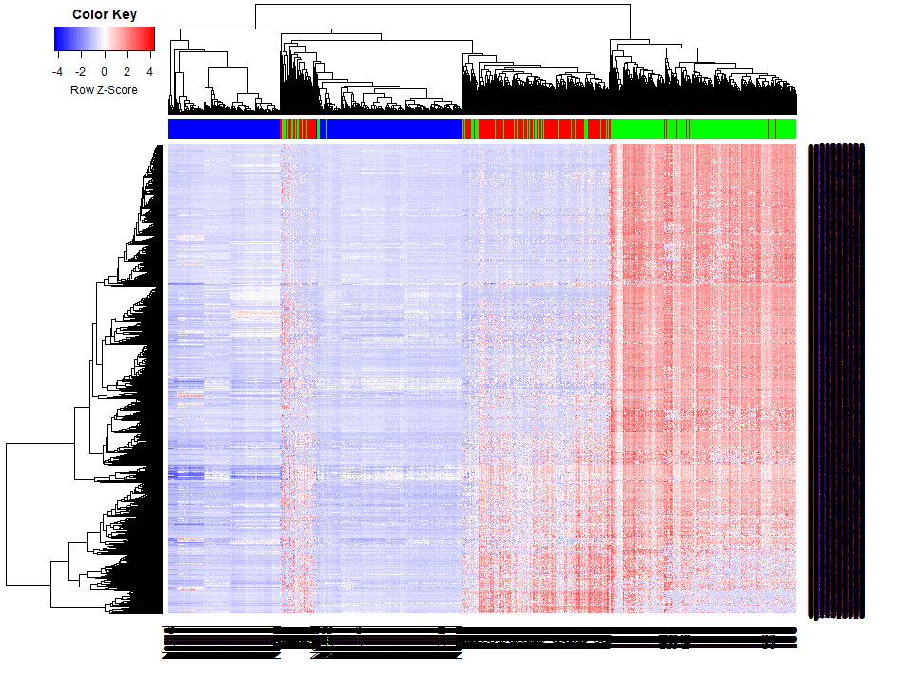

Figure 4. Final methylation biomarker and Cluster analysis to reveal diagnostic panel performance. With multiple filters, we eventually targeted 3,024 DNA methylation biomarkers in the discovery stage. This number can be decreased with higher threshold of effect size (ES) to methylation change between tumor and non-tumor samples. For example, when we set ES=0.4, we will have 285 markers remained and the cluster performance isn’t significantly weakened.

We applied random forest for feature selection to check the distribution of importance for each biomarker. In this analysis, we conducted the feature selection evaluation in two ways: 1) binary prediction, in which, the samples were divided into cancer (LGG and GBM) and non-cancer samples. 2) multi-class prediction, in which, the samples were divided into LGG, GBM and non-cancer samples. We found both of the prediction performance are perfect. In the first scenario, the sensitivity and specificity estimated in out-of-bag (OOB) of the prediction model are 99.83% and 99.3% and the error rate of the prediction is only 0.48%. Within the model, 157 CpGs shown Mean-Decrease-Gini >1 which indicating have powerful prediction performance. In the second scenario, only 1 normal samples were mistakenly classified to LGG and the remained normal were all predicted to normal, indicating the specificity is as high as 99.83%. 94.5% GBM and 83% LGG were classified to its own group while 79 LGG were predicted to GBM while 20 GBM were predicted to LGG.

In order to select a best biomarker panel which can be applied in MCRI samples, we need to evaluate the performance of DNA methylation biomarkers in GBM/LGG prediction with limited biomarkers. With random forest method, we found the prediction error rate is decreased as the increment of biomarker numbers. In the binary prediction scenario, the prediction accuracy could come up to 98% with ~3 biomarkers (**Figure 5A**) while in the 3-class classification scenario, the prediction accuracy could come up to 91% with ~ 5 biomarkers (**Figure 5B**).

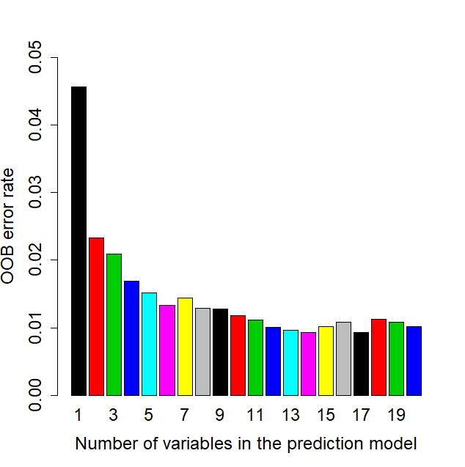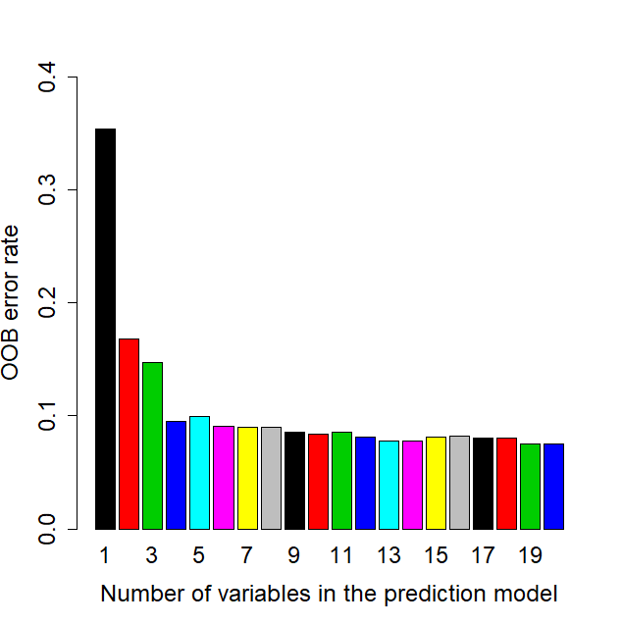

Figure 5. DNA methylation biomarker performance in random forest prediction models.

**Genome-wide DNA methylation of glioblastoma identified DNA methylation prognostic biomarkers**

DNA methylation have been demonstrated to be significantly associated with outcomes of human cancer. In order to identify prognosis biomarkers, I collected all the TCGA LGG and GBM methylation dataset which have comprehensive overall survival times (OS) so that we can identify the most interesting prognostic methylation biomarker for GBM and LGG. The overall survival time (OS) for 155 GBM and 534 LGG.

A (LGG) B (GBM)

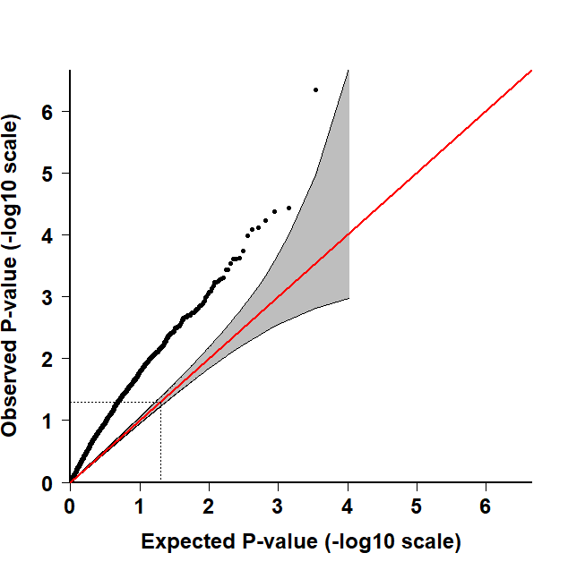 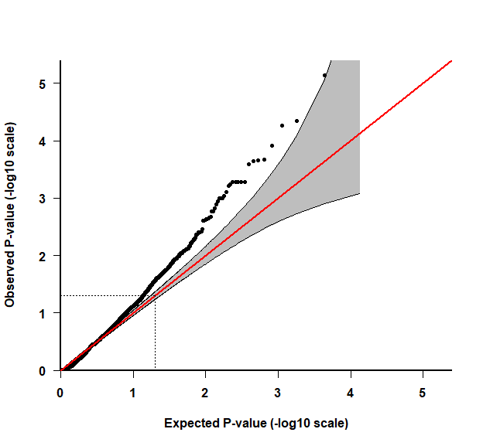

CDYL

ARHGEF7

NEUROD1

SCHIP1

Figure 6. DNA methylation biomarker performance in random forest prediction models.

We identified 5 genes including NEUROD1 (cg01431993), SCHIP1 (cg01654862 and cg05580655), NEUROD1 (cg20709008), ARHGEF7 (cg20749916) and CDYL (cg25026237) shown significant prognostic biomarker for GBM or LGG outcome (P<1.0x10-6).

cg20749916 (ARHGEF7) in LLG

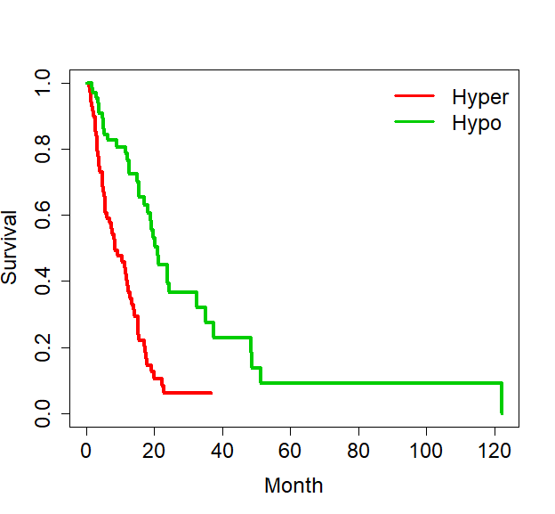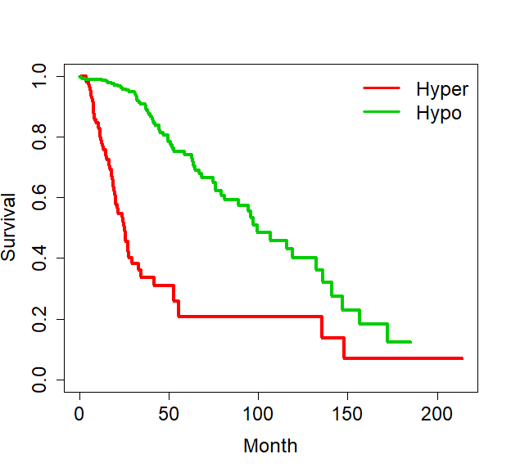

**P<0.000001**

**P<0.000001**

cg25026237 (CDYL) in GBM

Figure 7. DNA methylation status revealed by Roadmap and GEO based WGBS data

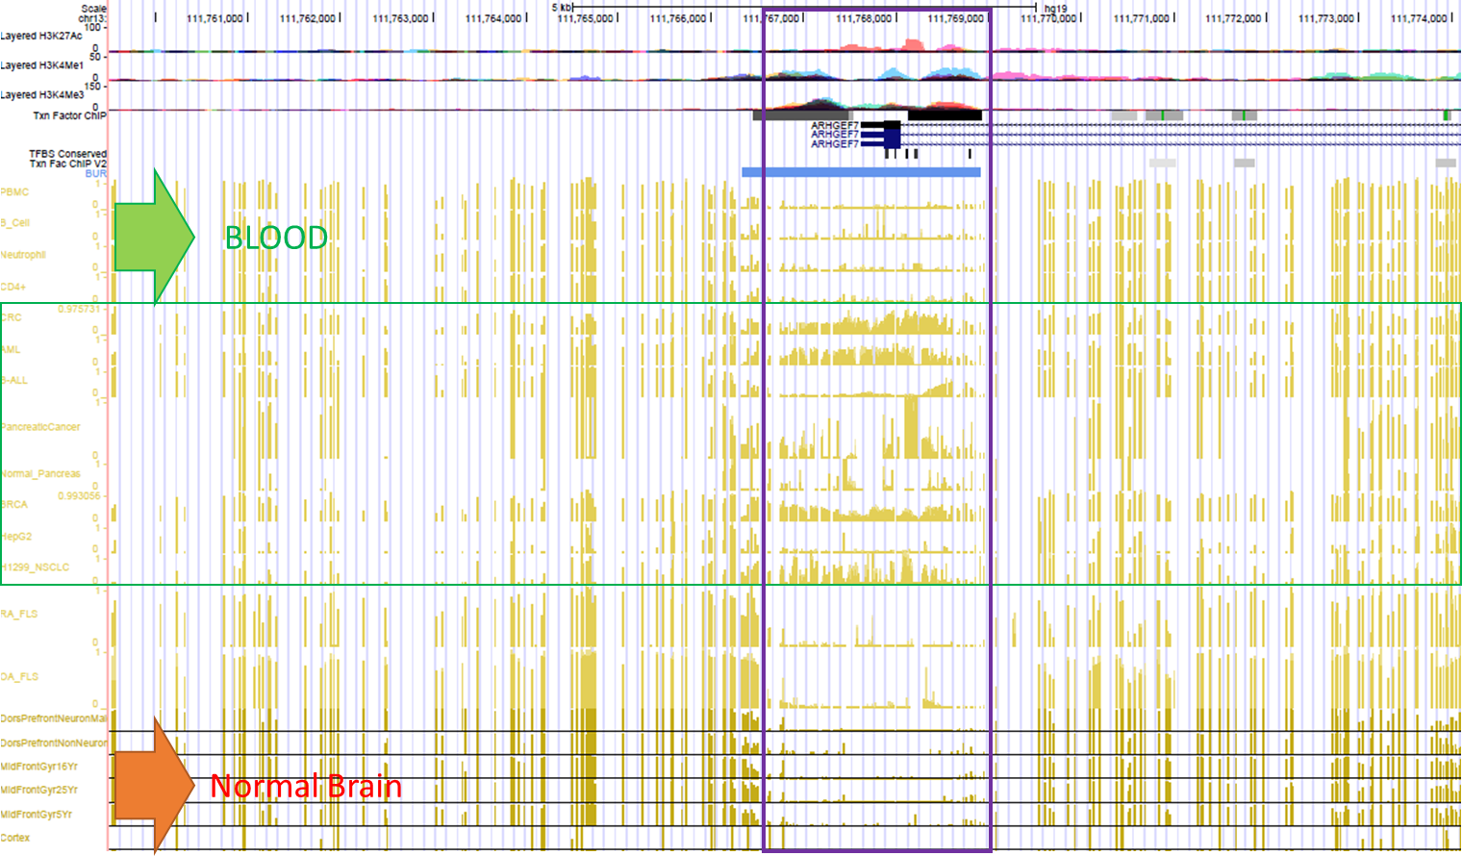

Figure 8. DNA methylation profiles of ARHGEF7 in human normal brain and other human normal or cancer tissues. We take ARHGEF7 as the example to show the hyper-methylated status of the promoter regions in human tissues (normal brain, normal blood and some other cancer tissues)

We checked some of the candidate DMRs and we found these biomarkers also shown hyper-methylated status in other human cancers such as liver cancer (HCC), breast cancer (BRCA), blood cancers (AML) as well pancreatic cancers while low-methylated in normal blood and normal human brain tissues. These evidences indicate the cell-free DNA methylation biomarker panel might have multiple roles in cancer diagnosis.

**Research Design and Methodology**

**Identification of DNA methylation based GBM/LGG diagnostic and prognostic biomarkers**

We designed a three-stage strategy to identify the most powerful DNA methylation based GBM/LGG diagnostic and prognostic biomarkers with comprehensive public dataset including GEO/ArrayExpress dataset, TCGA dataset, Roadmap Epigenomic dataset, NCI-60 DNA methylation dataset, ENCODE functional genome regulatory dataset. We also plan to collect some other related public dataset to provide more support to our final conclusion, including GSE121721, GSM941746, GSM669614, GSM669615, GSM669613, GSM669604, GSM669605 and GSM669603.

**DNA methylation measurement to solid tissue, cell-free DNA from cancer and high-risk carriers**

DNA methylation measurement have several different steps including DNA extraction, DNA bisulfite conversion and targeted-PCR based methylation sequencing (NGS). We already have parts of GBM/LGG solid tissues and cell-free DNA from tumor patients can be enrolled with different disease stages. Cell-free DNA from high-risk allele carrier can be extracted from MCRI personalized medicine research project (PMRP). DNA extraction is basic molecular biology experiments. DNA methylation bisulfite conversion is routine molecular assay which can be completed with

**Machine learning and multi-class classification**

We will apply multiple classification/machine learning algorithm to build the diagnostic and prognostic models based on solid tissue, cfDNA methylation from cancer patients and high-risk allele carrier. We will prepare a package for the multiple machine learning algorithms including random forest (RF), logistic regression (LR), support vector machine (SVM), Bayes tree (BT), K-nearest neighbors (KNN). According to my previous research, these method do have certain different performance in same dataset causing by the preferred data structure and characteristics. We will evaluate the performance of the different methods in GBM/LGG methylation dataset and provided a reference for the further methylation biomarker research.

**Timeline**

**Budget**

Sample Size: 384

|  |  |  |
| --- | --- | --- |
| Items | Each sample or total project | Sum (10,000 samples) |
| Nucleic Acid Isolation from Tissue | Done my MCRI | Free |
| Sodium bisulfite(500g) | 200$/500g | 200$ |
| SMARTer ThruPLEX Plasma-Seq Kit | 480 Rxns | 10,560$ |
| EZ DNA Methylation Kit | 475$/200Rxns | 912$ |
| Methylation Sequencing Primers (10 panels) | 13$/50nm | 130$ |
| Illumina Free Adapter Blocking Reagent | 12Rxns | 125$ |
| Nextera XT DNA Library Preparation Kit | 24Rxns | 860$ |
| QIAseq 96-Index I Set A | Plan B | 5037x3=15,111$/50nm |
| QIAseq 96-Index I Set B |
| QIAseq 96-Index I Set C |
| QIAquick Spin Columns (100) | 123$/100 | 123$x3.84= 472.32$ |
| DNA-seq library preparation | 2$ (PCR+30 libraries) | 2$x384=768$ |
| Mi-seq (50000x depth each insertion) | 750$/run(384 samples) | 1500$/run= 1500$ |
| Other chemistry or Consumables | -- | -- |
|  |  |  |

Total cost: 30638.32

**Literature Cited**

1. Feinberg AP, Vogelstein B. Hypomethylation distinguishes genes of some human cancers from their normal counterparts. Nature 1983;301:89-92.

2. Feinberg AP, Vogelstein B. Hypomethylation of ras oncogenes in primary human cancers. Biochem Biophys Res Commun 1983;111:47-54.

3. Brock MV, Hooker CM, Ota-Machida E, Han Y, Guo M, Ames S, Glockner S, et al. DNA methylation markers and early recurrence in stage I lung cancer. N Engl J Med 2008;358:1118-1128.

4. Fujiwara K, Fujimoto N, Tabata M, Nishii K, Matsuo K, Hotta K, Kozuki T, et al. Identification of epigenetic aberrant promoter methylation in serum DNA is useful for early detection of lung cancer. Clin Cancer Res 2005;11:1219-1225.

5. Han L, Kamdar MR. MRI to MGMT: predicting methylation status in glioblastoma patients using convolutional recurrent neural networks. Pac Symp Biocomput 2018;23:331-342.

6. Wei J, Yang G, Hao X, Gu D, Tan Y, Wang X, Dong D, et al. A multi-sequence and habitat-based MRI radiomics signature for preoperative prediction of MGMT promoter methylation in astrocytomas with prognostic implication. Eur Radiol 2019;29:877-888.

7. Jiang S, Rui Q, Wang Y, Heo HY, Zou T, Yu H, Zhang Y, et al. Discriminating MGMT promoter methylation status in patients with glioblastoma employing amide proton transfer-weighted MRI metrics. Eur Radiol 2018;28:2115-2123.

8. Jiang D, He Z, Wang C, Zhou Y, Li F, Pu W, Zhang X, et al. Epigenetic silencing of ZNF132 mediated by methylation-sensitive Sp1 binding promotes cancer progression in esophageal squamous cell carcinoma. Cell Death Dis 2018;10:1.

9. Lei Y, Liu L, Zhang S, Guo S, Li X, Wang J, Su B, et al. Hdac7 promotes lung tumorigenesis by inhibiting Stat3 activation. Mol Cancer 2017;16:170.

10. He Y, Cui Y, Wang W, Gu J, Guo S, Ma K, Luo X. Hypomethylation of the hsa-miR-191 locus causes high expression of hsa-mir-191 and promotes the epithelial-to-mesenchymal transition in hepatocellular carcinoma. Neoplasia 2011;13:841-853.

11. Lan Q, Liu PY, Haase J, Bell JL, Huttelmaier S, Liu T. The Critical Role of RNA m(6)A Methylation in Cancer. Cancer Res 2019.

12. Hegi ME, Diserens AC, Gorlia T, Hamou MF, de Tribolet N, Weller M, Kros JM, et al. MGMT gene silencing and benefit from temozolomide in glioblastoma. N Engl J Med 2005;352:997-1003.

13. Chae YC, Kim JY, Park JW, Kim KB, Oh H, Lee KH, Seo SB. FOXO1 degradation via G9a-mediated methylation promotes cell proliferation in colon cancer. Nucleic Acids Res 2019;47:1692-1705.

14. Oshima G, Poli EC, Bolt MJ, Chlenski A, Forde M, Jutzy JMS, Biyani N, et al. DNA Methylation Controls Metastasis-Suppressive 14q32-Encoded miRNAs. Cancer Res 2019;79:650-662.

15. Chaudhry P, Srinivasan R, Patel FD. Utility of gene promoter methylation in prediction of response to platinum-based chemotherapy in epithelial ovarian cancer (EOC). Cancer Invest 2009;27:877-884.

16. Guo S, Diep D, Plongthongkum N, Fung HL, Zhang K, Zhang K. Identification of methylation haplotype blocks aids in deconvolution of heterogeneous tissue samples and tumor tissue-of-origin mapping from plasma DNA. Nat Genet 2017;49:635-642.

17. Agirre X, Vizmanos JL, Calasanz MJ, Garcia-Delgado M, Larrayoz MJ, Novo FJ. Methylation of CpG dinucleotides and/or CCWGG motifs at the promoter of TP53 correlates with decreased gene expression in a subset of acute lymphoblastic leukemia patients. Oncogene 2003;22:1070-1072.

18. Weller M, Tabatabai G, Kastner B, Felsberg J, Steinbach JP, Wick A, Schnell O, et al. MGMT Promoter Methylation Is a Strong Prognostic Biomarker for Benefit from Dose-Intensified Temozolomide Rechallenge in Progressive Glioblastoma: The DIRECTOR Trial. Clin Cancer Res 2015;21:2057-2064.

19. Hegi ME, Diserens AC, Godard S, Dietrich PY, Regli L, Ostermann S, Otten P, et al. Clinical trial substantiates the predictive value of O-6-methylguanine-DNA methyltransferase promoter methylation in glioblastoma patients treated with temozolomide. Clin Cancer Res 2004;10:1871-1874.

20. Yi JM, Tsai HC, Glockner SC, Lin S, Ohm JE, Easwaran H, James CD, et al. Abnormal DNA methylation of CD133 in colorectal and glioblastoma tumors. Cancer Res 2008;68:8094-8103.

21. Lopez-Gines C, Navarro L, Munoz-Hidalgo L, Buso E, Morales JM, Gil-Benso R, Gregori-Romero M, et al. Association between epidermal growth factor receptor amplification and ADP-ribosylation factor 1 methylation in human glioblastoma. Cell Oncol (Dordr) 2017;40:389-399.

22. Ghasemi A, Fallah S, Ansari M. MiR-153 as a Tumor Suppressor in Glioblastoma Multiforme is Downregulated by DNA Methylation. Clin Lab 2016;62:573-580.

23. Ayala-Ortega E, Arzate-Mejia R, Perez-Molina R, Gonzalez-Buendia E, Meier K, Guerrero G, Recillas-Targa F. Epigenetic silencing of miR-181c by DNA methylation in glioblastoma cell lines. BMC Cancer 2016;16:226.

24. Ma J, Hou X, Li M, Ren H, Fang S, Wang X, He C. Genome-wide methylation profiling reveals new biomarkers for prognosis prediction of glioblastoma. J Cancer Res Ther 2015;11 Suppl 2:C212-215.

25. Jha P, Pia Patric IR, Shukla S, Pathak P, Pal J, Sharma V, Thinagararanjan S, et al. Genome-wide methylation profiling identifies an essential role of reactive oxygen species in pediatric glioblastoma multiforme and validates a methylome specific for H3 histone family 3A with absence of G-CIMP/isocitrate dehydrogenase 1 mutation. Neuro Oncol 2014;16:1607-1617.

26. Lai RK, Chen Y, Guan X, Nousome D, Sharma C, Canoll P, Bruce J, et al. Genome-wide methylation analyses in glioblastoma multiforme. PLoS One 2014;9:e89376.

27. Zhang W, Yan W, You G, Bao Z, Wang Y, Liu Y, You Y, et al. Genome-wide DNA methylation profiling identifies ALDH1A3 promoter methylation as a prognostic predictor in G-CIMP- primary glioblastoma. Cancer Lett 2013;328:120-125.

28. Sun X, St John JC. Modulation of mitochondrial DNA copy number in a model of glioblastoma induces changes to DNA methylation and gene expression of the nuclear genome in tumours. Epigenetics Chromatin 2018;11:53.

29. Serrano J, Snuderl M. Whole Genome DNA Methylation Analysis of Human Glioblastoma Using Illumina BeadArrays. Methods Mol Biol 2018;1741:31-51.

30. Tran A, Escovedo C, Migdall-Wilson J, Chou AP, Chen W, Cloughesy T, Nelson S, et al. In Silico Enhanced Restriction Enzyme Based Methylation Analysis of the Human Glioblastoma Genome Using Agilent 244K CpG Island Microarrays. Front Neurosci 2009;3:57.

31. Jovcevska I. Sequencing the next generation of glioblastomas. Crit Rev Clin Lab Sci 2018;55:264-282.

32. Barault L, Amatu A, Bleeker FE, Moutinho C, Falcomata C, Fiano V, Cassingena A, et al. Digital PCR quantification of MGMT methylation refines prediction of clinical benefit from alkylating agents in glioblastoma and metastatic colorectal cancer. Ann Oncol 2015;26:1994-1999.

33. Ramirez JL, Taron M, Balana C, Sarries C, Mendez P, de Aguirre I, Nunez L, et al. Serum DNA as a tool for cancer patient management. Rocz Akad Med Bialymst 2003;48:34-41.

34. Bloch O, Lim M, Sughrue ME, Komotar RJ, Abrahams JM, O'Rourke DM, D'Ambrosio A, et al. Autologous Heat Shock Protein Peptide Vaccination for Newly Diagnosed Glioblastoma: Impact of Peripheral PD-L1 Expression on Response to Therapy. Clin Cancer Res 2017;23:3575-3584.

35. Reynes G, Vila V, Fleitas T, Reganon E, Font de Mora J, Jorda M, Martinez-Sales V. Circulating endothelial cells and procoagulant microparticles in patients with glioblastoma: prognostic value. PLoS One 2013;8:e69034.

36. Rosell R, de Las Penas R, Balana C, Santarpia M, Salazar F, de Aguirre I, Reguart N, et al. Translational research in glioblastoma multiforme: molecular criteria for patient selection. Future Oncol 2008;4:219-228.

37. Faria G, Silva E, Da Fonseca C, Quirico-Santos T. Circulating Cell-Free DNA as a Prognostic and Molecular Marker for Patients with Brain Tumors under Perillyl Alcohol-Based Therapy. Int J Mol Sci 2018;19.

38. Edgar R, Domrachev M, Lash AE. Gene Expression Omnibus: NCBI gene expression and hybridization array data repository. Nucleic Acids Res 2002;30:207-210.

39. Brazma A, Parkinson H, Sarkans U, Shojatalab M, Vilo J, Abeygunawardena N, Holloway E, et al. ArrayExpress--a public repository for microarray gene expression data at the EBI. Nucleic Acids Res 2003;31:68-71.

40. Roadmap Epigenomics C, Kundaje A, Meuleman W, Ernst J, Bilenky M, Yen A, Heravi-Moussavi A, et al. Integrative analysis of 111 reference human epigenomes. Nature 2015;518:317-330.

41. Shankavaram UT, Varma S, Kane D, Sunshine M, Chary KK, Reinhold WC, Pommier Y, et al. CellMiner: a relational database and query tool for the NCI-60 cancer cell lines. BMC Genomics 2009;10:277.

42. Kong J, Cooper LA, Wang F, Gutman DA, Gao J, Chisolm C, Sharma A, et al. Integrative, multimodal analysis of glioblastoma using TCGA molecular data, pathology images, and clinical outcomes. IEEE Trans Biomed Eng 2011;58:3469-3474.

43. Li Y, Zhu J, Tian G, Li N, Li Q, Ye M, Zheng H, et al. The DNA methylome of human peripheral blood mononuclear cells. PLoS Biol 2010;8:e1000533.

44. Guo S, Zhu Q, Jiang T, Wang R, Shen Y, Zhu X, Wang Y, et al. Genome-wide DNA methylation patterns in CD4+ T cells from Chinese Han patients with rheumatoid arthritis. Mod Rheumatol 2017;27:441-447.

45. Ding W, Pu W, Wang L, Jiang S, Zhou X, Tu W, Yu L, et al. Genome-Wide DNA Methylation Analysis in Systemic Sclerosis Reveals Hypomethylation of IFN-Associated Genes in CD4(+) and CD8(+) T Cells. J Invest Dermatol 2018;138:1069-1077.

46. Consortium EP. The ENCODE (ENCyclopedia Of DNA Elements) Project. Science 2004;306:636-640.